**Vision College Logo**

# Diploma in Software Engineering and Design

# Assignment Cover Sheet

|  |  |
| --- | --- |
| Course name: Diploma in Software Engineering and Design | **Student’s name: David Simcox** |
| **Assignment title and/or number**: Mobile app development using a local database | |
| **Assessment weighting** | *15 credits,*  *12.5% of the overall programme.* |
| **Due date**: 21st August 2015 | **Date submitted**:  (late submissions incur 10% penalty, after 7 days late, the assessment will not be marked) |
| **Assessment conditions:** | This is a resource-based assessment. This means that you may have access to any relevant resources to assist you. This could include, for example, your learning materials, information on the Internet, and so on. However, all work must be your own with no assistance from any other person. |
| **Submission requirements:** | You’re required to submit the following into your assignment submission directory:   * This document, completed where appropriate * SQLite Database file * Visual Studio or Xamarin project files * Testing Sheet attached   Also upload your assessment on Github and share your repository link |

|  |  |  |  |  |  |  |  |  |  |  |  |  |  |
| --- | --- | --- | --- | --- | --- | --- | --- | --- | --- | --- | --- | --- | --- |
| **Assignment Checklist:** | |  |  | | --- | --- | | **Requirement** | **Completed** | | Database | ✓ | | User interface | ✓ | | Functionality | ✓ | | Coding | ✓ | | Testing | ✓ | |

# Disclaimer of Plagiarism and Collusion

I declare that, to the best of my knowledge, this assessment is my own work, and has not been copied from any other student's work or from any other source.

Enter your name here to indicate you agree to the above statement.

|  |
| --- |
| David Simcox |

**You have to design and code one of the two apps below**

1. A Note Taking App
2. Hangman

**Note Taking App**

**Requirement**

This assessment consists of building an app that allows users to take notes and stores them sequentially according to the date entered.

**Functionality Requirement**

1. **Adding a Note**

**(Add a title and description field)**

1. **Displaying a list of Notes**

**(Display the title and the date entered)**

1. **Viewing a Note**
2. **Updating a Note**
3. **Deleting a Note**
4. **Searching for a Note**

**User Interface requirement**

1. **Design your UI for different screen sizes**

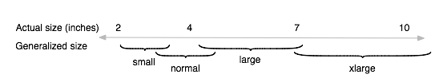

Have a look at the android best practices guide to support different screen sizes

[http://developer.android.com/guide/practices/screens_support.html#screen-independence](http://developer.android.com/guide/practices/screens_support.html%23screen-independence)

1. **Design a splash screen for your app with your name on it.**
2. **Design an Icon for your app**

**Have a look at the following links to generate images of different screen densities and also making launcher icons**

[**https://romannurik.github.io/AndroidAssetStudio/nine-patches.html**](https://romannurik.github.io/AndroidAssetStudio/nine-patches.html)

[**https://romannurik.github.io/AndroidAssetStudio/icons-launcher.html**](https://romannurik.github.io/AndroidAssetStudio/icons-launcher.html)

**Platform requirement**

1. **Your App needs to support Android 4.4 and up**

**UI Design**

1. Below is the sample UI design. You can choose your color combination and layout. You are free to decide on the layout controls such as a list view, tab control, view pager, navigation bar etc.

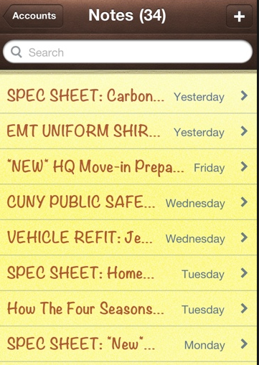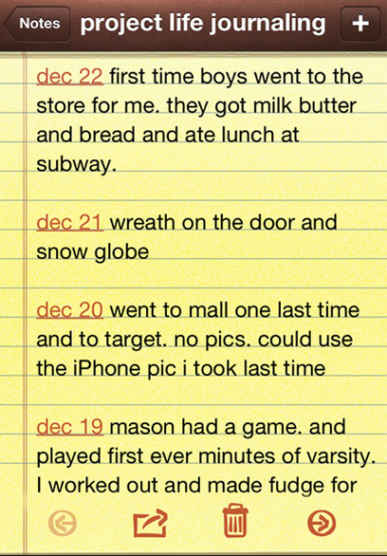

**Testing Requirements**

Have a look at the testing sheet at the end of the assessment

**Hangman**

**Requirement**

The assessment consists of designing a Hangman game for the Android platform.

**Functionality Requirement**

1. Simulate the Hangman game
2. Store the list of words in a database
3. Set up a scoring system
4. Store user high scores

**User Interface requirement**

1. **Design your UI for different screen sizes**



Have a look at the android best practices guide to support different screen sizes

[http://developer.android.com/guide/practices/screens_support.html#screen-independence](http://developer.android.com/guide/practices/screens_support.html%23screen-independence)

1. **Design a splash screen for your app**
2. **Design an Icon for your app**

**Platform requirement**

1. **Your App needs to support Android 4.4 and up**

**UI Design**

Below is the sample UI design for the app. You can choose your color combination and layout

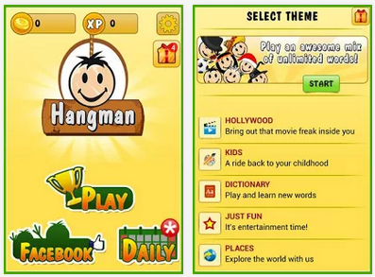 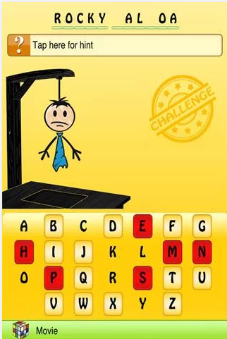

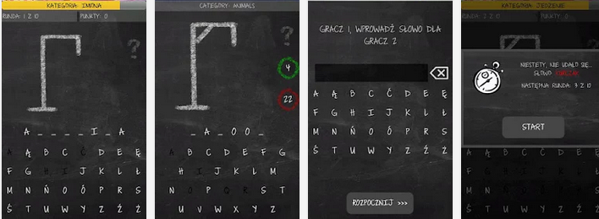

**Screenshots**

Kindly take screenshots of your app and add your app screenshots in a separate folder in your project solution.

**Testing Requirements**

Have a look at the testing sheet at the end of the assessment

**Submission**

Kindly submit your project in your students drive under your name.

Also upload your project on Github and enter your repository link below.

|  |
| --- |
| **Github repository link** |
| https://github.com/DrZeusNZ/HangBunny |

**Marking**

|  |  |
| --- | --- |
| **Marking Schedule** |  |
| Program Functionality | **50** |
| App design and UI look | **10** |
| Coding standards | **20** |
| Creativity | **10** |
| Testing | **10** |

**Testing Sheet**

Kindly fill in the testing sheet below with your comments. These are the common quality checks you would perform before uploading your app on the Google play store.

Some common test procedures for an android app can also be found on the Google developer website.

<http://developer.android.com/distribute/googleplay/quality/core.html>

|  |  |  |  |
| --- | --- | --- | --- |
|  | **Test Condition** | **Result (Pass/Fail)** | **Comments** |
| **App Design** | Navigate to all parts of the app — all screens, dialogs, settings, and all user flows.  **Platforms to Test**  Android 4.4  Android 5.0  Android 5.1 | PASS | Ran on 4.4 Phone  Complied with 4.4,5.0,5.1 |
| Navigate to all parts of the app — all screens, dialogs, settings, and all user flows  **Screen sizes to Test**  4’ inch  5’ inch  7’ inch  10’ inch   1. App displays graphics, text, images, and other UI elements without noticeable distortion, blurring, or pixilation. 2. App provides high-quality graphics for all targeted screen sizes and form factors, including for [larger-screen devices such as tablets](http://developer.android.com/distribute/essentials/quality/tablet.html). 3. No aliasing at the edges of menus, buttons, and other UI elements is visible. 4. Composition is acceptable in all supported form factors, including for larger-screen devices such as tablets. 5. No cut-off letters or words are visible. 6. No improper word wraps within buttons or icons are visible. 7. Sufficient spacing between text and surrounding elements. | PASS | All elements readable and accessible. |
| **App State**  App preserves user or app state when leaving the foreground and prevents accidental data loss due to back-navigation and other state changes. When returning to the foreground, the app must restore the preserved state and any significant stateful transaction that was pending, such as changes to editable fields, game progress, menus, videos, and other sections of the app or game. | From each app screen, press the device's Home key, then re-launch the app from the All Apps screen.  When the app is re-launched from Home or All Apps, the app restores the app state as closely as possible to the previous state | PASS |  |
| From each app screen, switch to another running app and then return to the app under test using the Recent’s app switcher.  When the app is resumed from the Recent’s app switcher, the app returns the user to the exact state in which it was last used. | PASS |  |
| From each app screen (and dialogs), press the Back button.  On Back key presses, the app gives the user the option of saving any app or user state that would otherwise be lost on back-navigation. | PASS | Back key handled when needed to manage the back stack |
| From each app screen, rotate the device between landscape and portrait orientation.  The App should correctly preserve and restore user or app state. | PASS | Screen rotation is locked |
| **Stability and Performance** | App does not crash, force close, freeze, or otherwise function abnormally on any targeted device.  App loads quickly or provides onscreen feedback to the user (a progress indicator or similar cue) if the app takes longer than two seconds to load. | PASS |  |

**Marking Schedule**

|  |  |  |  |  |
| --- | --- | --- | --- | --- |
| **% of Grade** | **Excellent 100%** | **Adequate 80%** | **Poor 60%** | **Not Met 0%** |
| App design and  User Interface  10% | Simple easy to use intuitive UI, no errors spelling mistake and good color schemes used | Minor errors with the UI, minor layout issues | Major UI errors making it hard to understand | Significant UI errors with no logical sense and program crash |
| Program Functionality  50% | No errors, program always works correctly and meets the specification | Minor details of the program specification are violated, program functions incorrectly for some inputs. | Significant details of the specification are violated, program often exhibits incorrect behavior. | Program only functions correctly in very limited cases or not at all |
| Coding  Standards    20% | No errors, code uses the best approach in every case and follows the coding standards | Minor errors or repetition of code, coding and naming standards not followed in some occasions | Code uses poorly-chosen approaches in some places. Naming standards not followed in some places. | Many things in the code could have been accomplished in an easier, faster, or otherwise better fashion. Poor naming and coding standards |
| Creativity  10% | Creative approach used for the app design, layout and functionality | Some creative aspects in the app design, layout and functionality | Not much creativity, the app is basic in terms of design, layout and functionality | NA |
| Testing  10% | Program is well tested to identify and fix bugs and errors. No major bugs or defects in the program. Testing results matches the actual program. | Program is well tested to identify most of the bugs, but some bugs still exist.  Some test cases marked pass which are false | Program has a lot of major bugs and is not tested. Testing sheet incorrect or incompletely filled out. | Program is not at all tested and testing sheet is not filled. |